BUILDING A MULTI-SERVICE APPLICATION WITH IN-PLACE UPGRADES ON KUBERNETES

The first step is to download the .exe file of Kubernetes

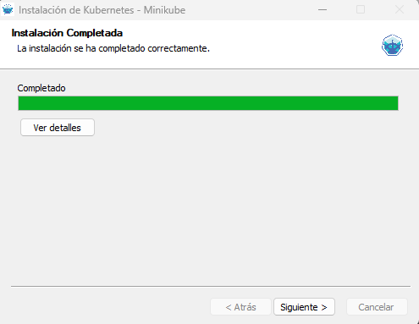

After installing it, we open the terminal to start minikube



Once we have started minikube, we will run the command “minikube get nodes” to check our nodes



The second step, after setting this up, is to create a folder called “backend” where we will store all the backend code of the application

We will start by creating the application’s API with the following code

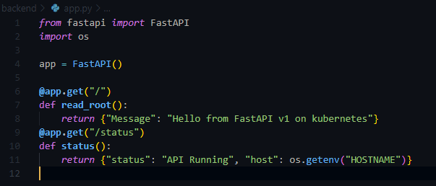

Once the API is created, we will create a .txt file for the requirements



Once the requirements.txt file is created, we will create a Dockerfile for the API

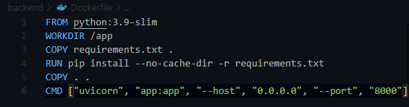

After creating the docker file, we will build the image in docker desktop



After building the image, we will move on to the frontend of the application

We will start by creating the folder called “frontend” and creating a file named “server.js”

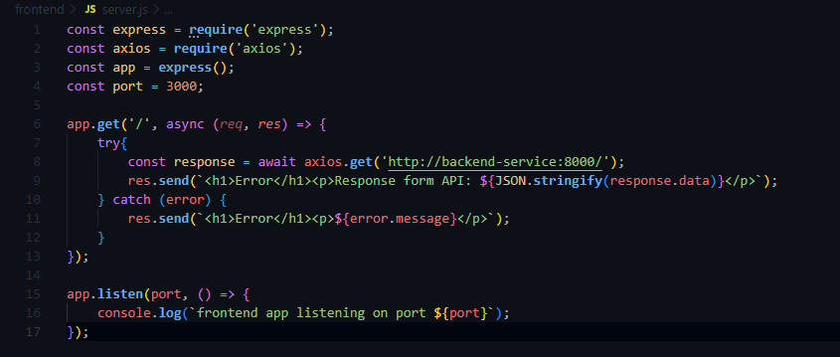

Next, we will create another file named “package. Json”

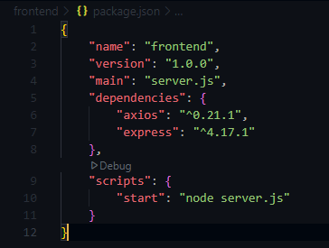

Next, we will create another Dockerfile with the following code

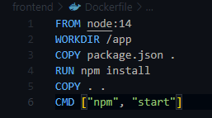

Once all of that is done, we will build the frontend image



As the third step, we will start by creating a backend deployment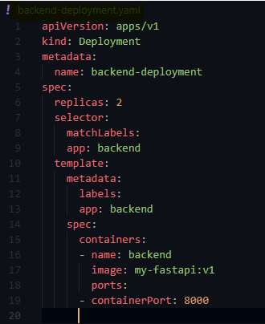

Next, we will proceed with creating the frontend deployment

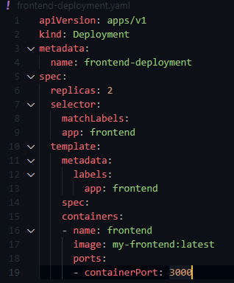

Now, we will create the Kubernetes configurations

* Backend service

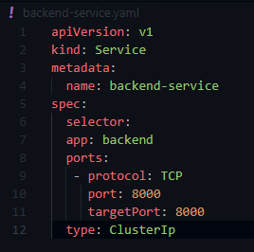

* Frontend service

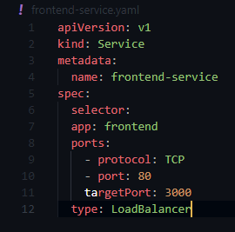

Later we deploy everything









For the frontend run the next command

